**ACROPOLIS INSTITUTE OF TECHNOLOGY AND RESEARCH**

**DEPARTMENT OF COMPUTER SCIENCE AND INFORMATION TECHNOLOGY**

**JAVA PROGRAMS DONE IN THE CLASS/LAB**

**\*\*To be uploaded on Github + Classwork copy\*\***

1. How to Print an Integer entered by an user
2. Write a program to demonstrate usage of Primitive Data types – Boolean, char, byte, short, int, long, float and double
3. Swap two numbers using temporary variable
4. Check whether a number is even or odd using if...else statement
5. Check whether an alphabet is vowel or consonant using if..else statement
6. Check if a Number is Positive or Negative using if else
7. Sum of Natural Numbers using for loop
8. Find Factorial of a number using for loop
9. Generate Multiplication Table using for loop
10. Display uppercased alphabet A to Z using for loop
11. Find GCD of two numbers using for loop and if statement
12. Java Program to Reverse the number
13. Demonstrate creating a class and Instance(object)
14. Demonstrate using Instance/class Variable in a Java Program by creating a simple public class
15. Demonstrate the java class using getter setter method for accessing private data members
16. Demonstrate the use of static variable
17. Demonstrate the use of static method
18. Demonstrate the use Scanner class for taking Input /Output from user
19. Create a program in java to create a class named Light. It contains a variable: On and two methods: switchOn() and switchOff(). Inside the Main class, create two objects: led and halogen of the Light class. Then use the objects to call the methods of the class.

**led.turnOn()** - It sets the On variable to true and prints the output.

**halogen.turnOff()** - It sets the On variable to false and prints the output.

1. Create a program in java to create a class Box with private members as length, breadth, height. Create two methods **getDimension() , setDimension()** to set and get values. Create instances of this class to call the methods.

**//1.How to Print an Integer entered by an user**

import java.util.*;

class Program1

{

public static void main(String a[])

{

System.out.println("Enter an Integer:-");

Scanner sc=new Scanner(System.in);

int x=sc.nextInt();

System.out.println("Entered Integer is " + x);

}

}

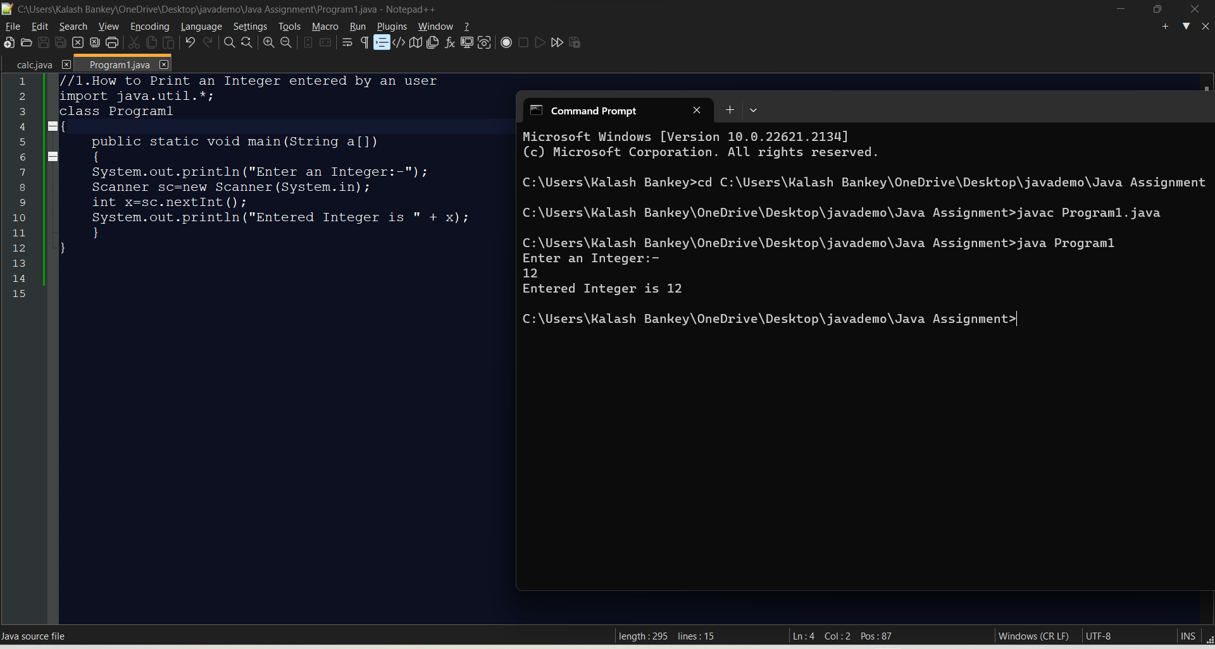

**//2.Write a program to demonstrate usage of Primitive Data types – Boolean, char, byte, short, int, long, float and double**

class Program2

{

public static void main(String ar[])

{

boolean f = false;

char a = 'A';

byte x = 127;

short y = 32767;

int x1 = 2147483647;

long y1 = 9223372036854775807l;

float z = 1;

double z1 = 1.2;

System.out.println("boolean value = " + f);

System.out.println("char value = " + a);

System.out.println("byte value = " + x);

System.out.println("short value = " + y);

System.out.println("int value = " + x1);

System.out.println("long value = " + y1);

System.out.println("float value = " + z);

System.out.println("double value = " + z1);

}

}

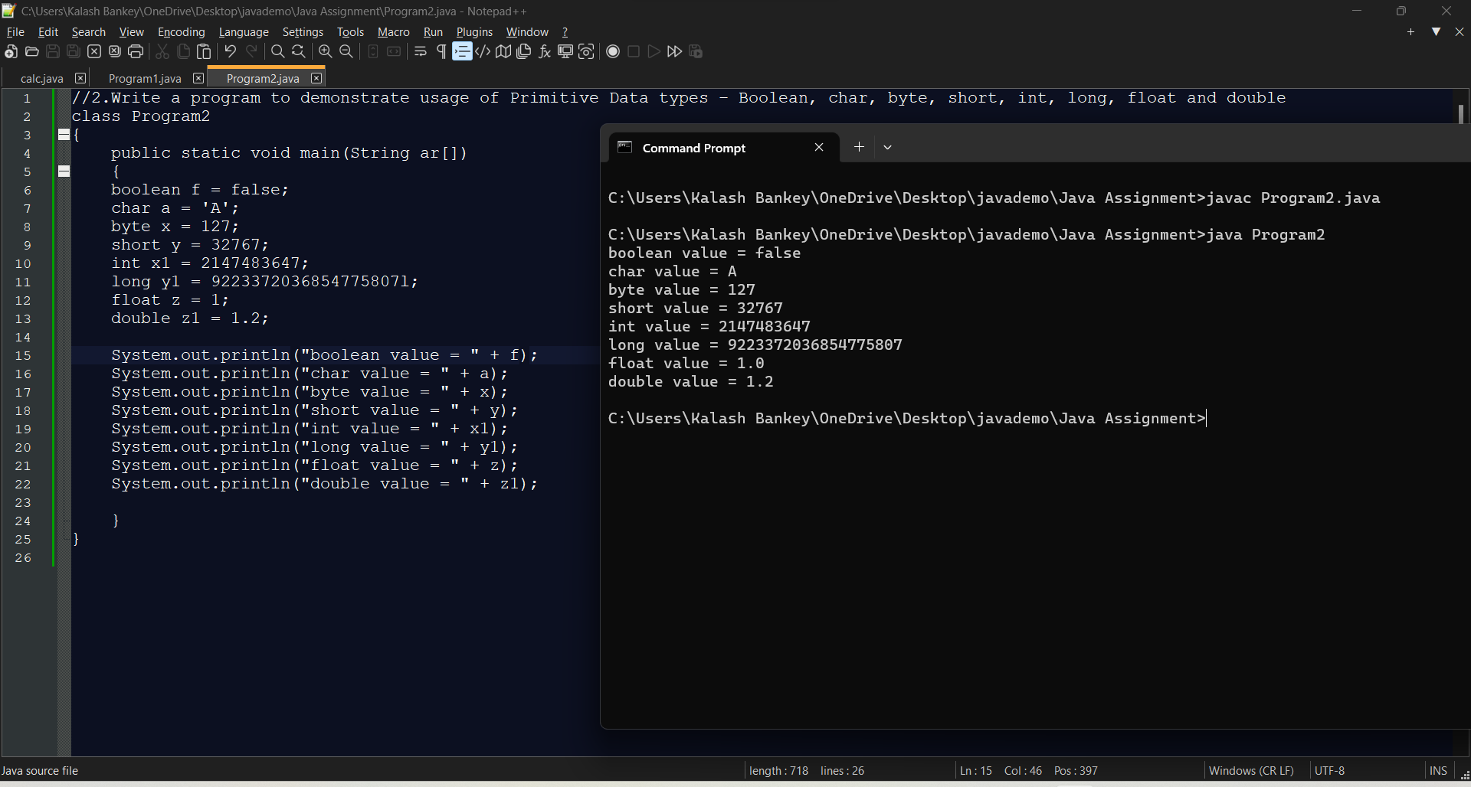

**//3.Swap two numbers using temporary variable**

import java.util.*;

class Program3

{

public static void main(String a[])

{

System.out.println("Enter two Integers:-");

Scanner sc=new Scanner(System.in);

int x=sc.nextInt();

int y=sc.nextInt();

int t;

System.out.println("Before Swapping");

System.out.println("x = " + x);

System.out.println("y = " + y);

t=x;

x=y;

y=t;

System.out.println("After Swapping");

System.out.println("x = " + x);

System.out.println("y = " + y);

}

}

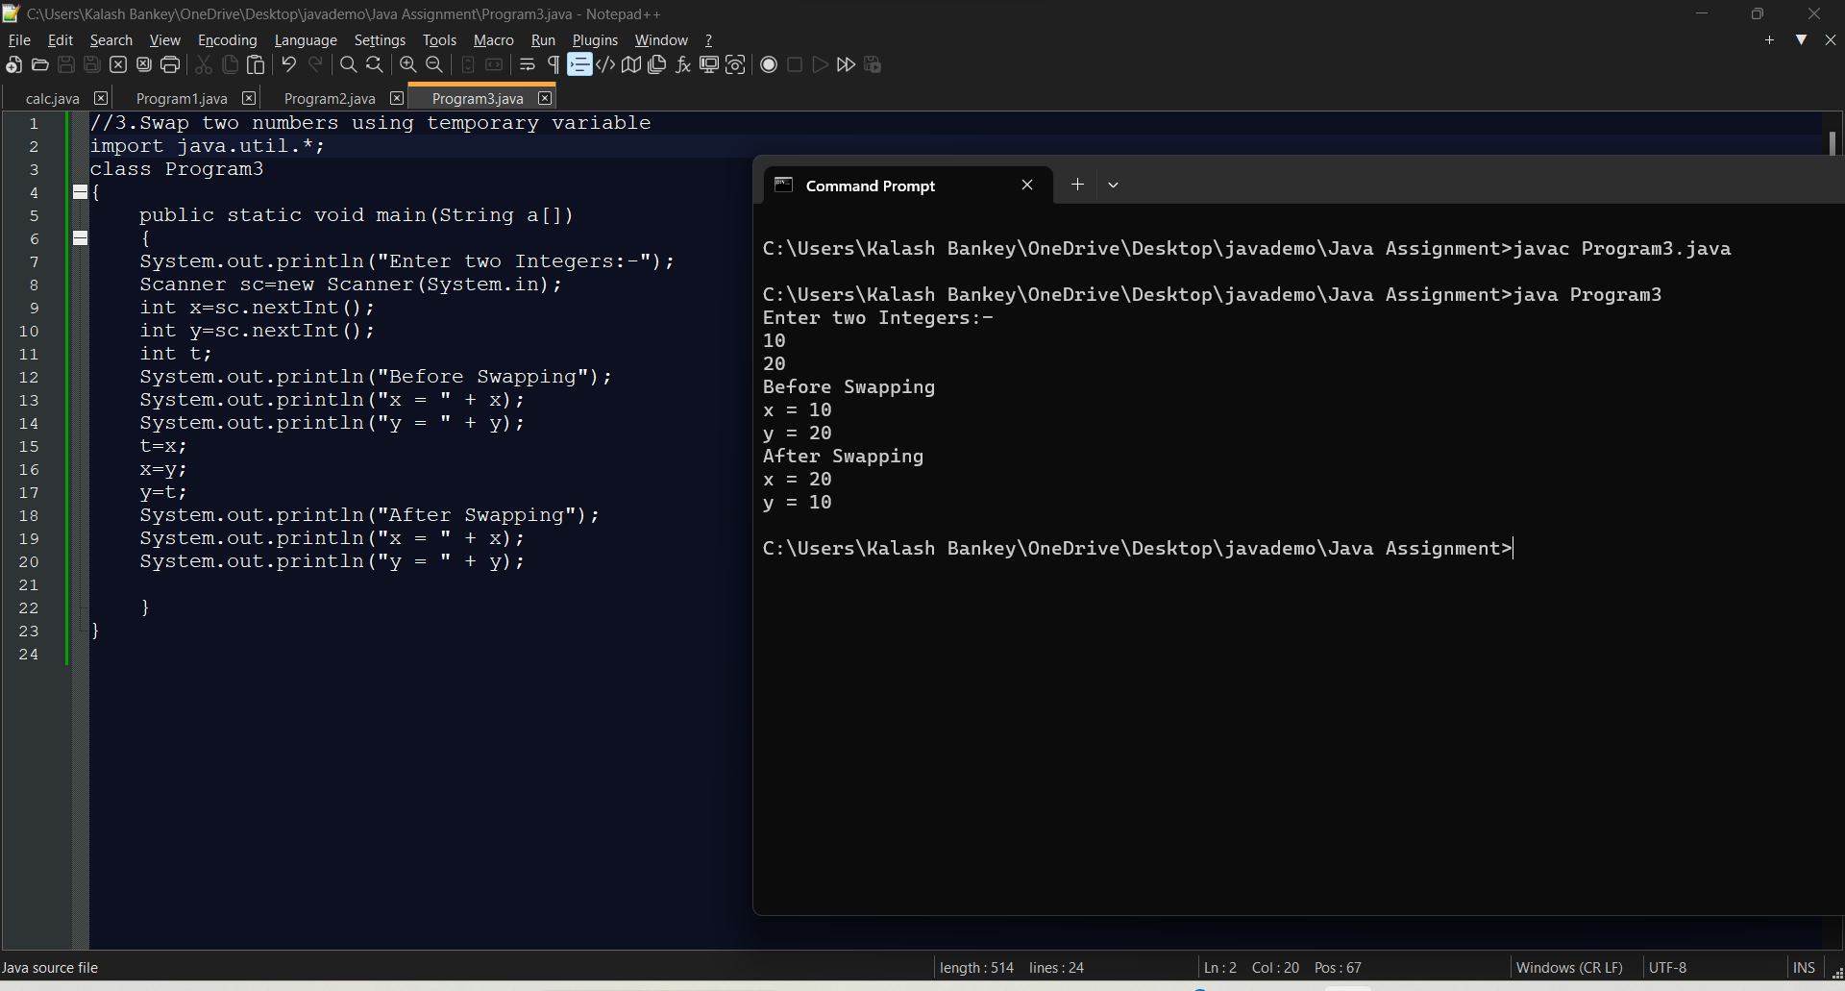

**//4.Check whether a number is even or odd using if...else statement**

import java.util.*;

class Program4

{

public static void main(String a[])

{

System.out.println("Enter a number:-");

Scanner sc=new Scanner(System.in);

int x=sc.nextInt();

if(x%2==0)

{

System.out.println(x+" is even number.");

}

else

{

System.out.println(x+" is odd number.");

}

}

}

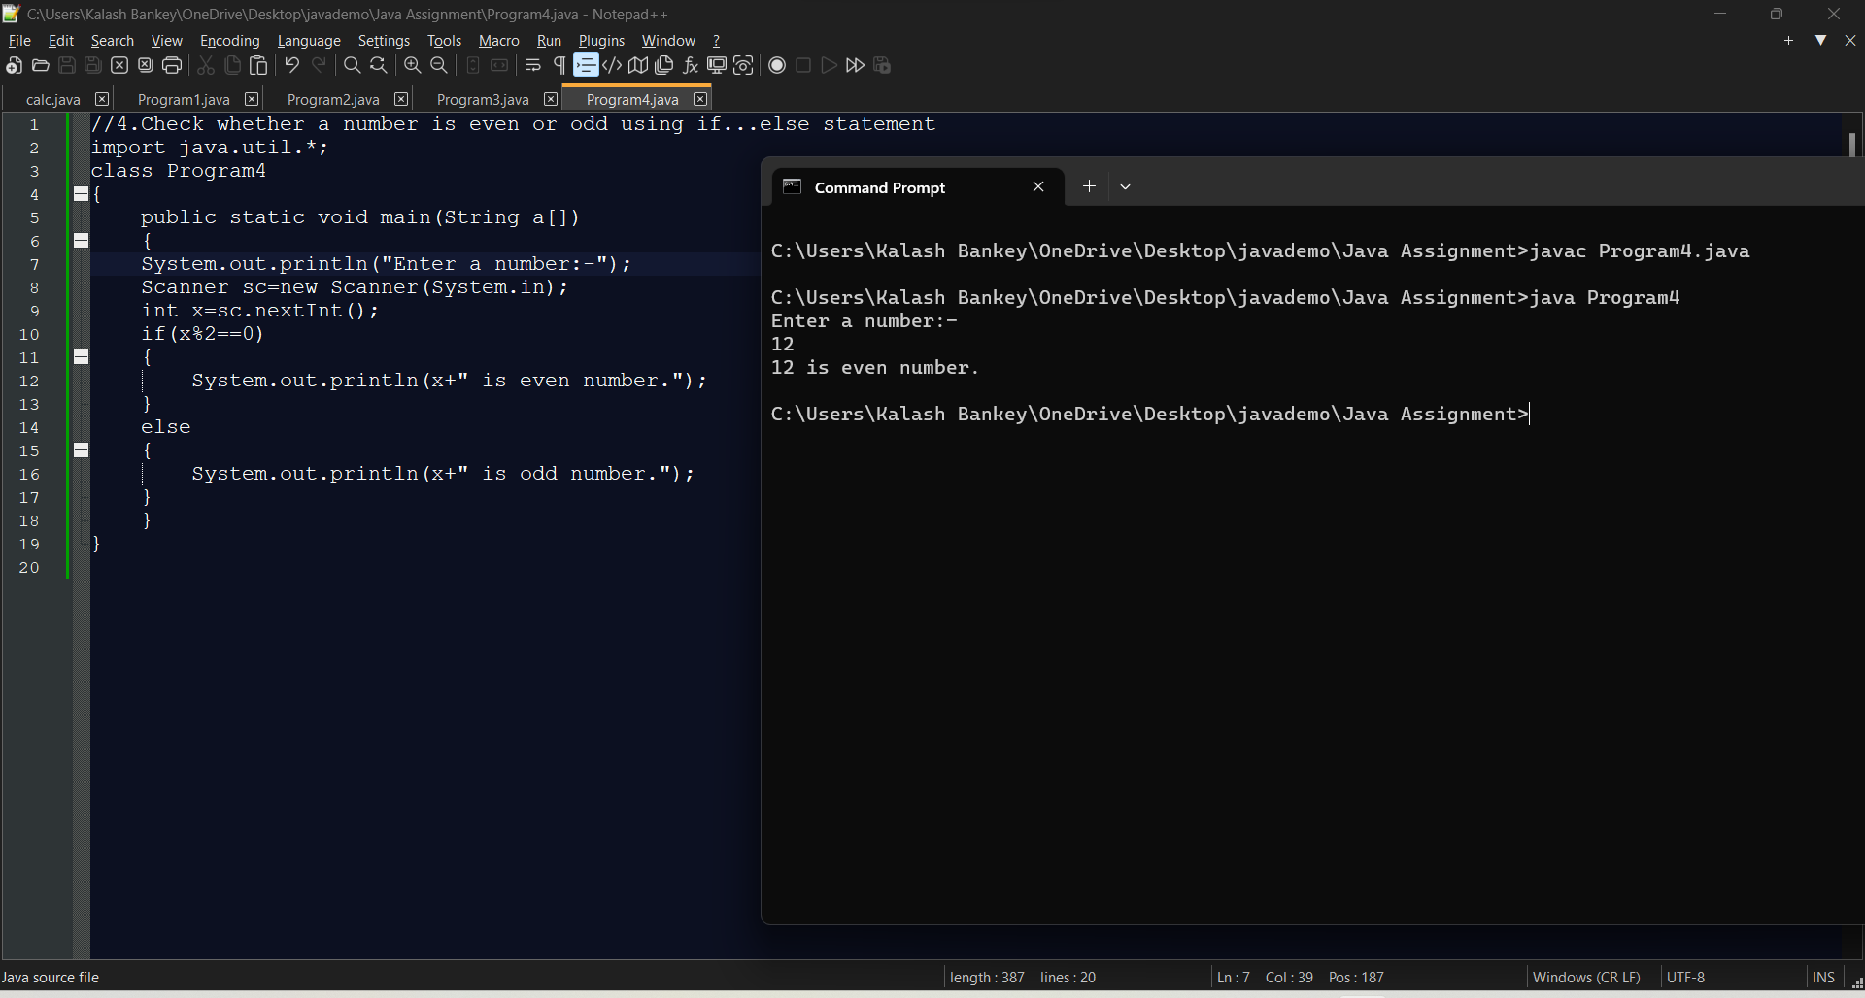

**//5.Check whether an alphabet is vowel or consonant using if..else statement**

import java.util.*;

class Program5

{

public static void main(String a[])

{

System.out.println("Enter an alphabet");

Scanner sc=new Scanner(System.in);

char x=sc.next().charAt(0);

char ch[]={'a','e','i','o','u'};

int c=0;

for(int i=0;i<5;i++)

{

if(ch[i]==x)

{

c=1;

}

}

if(c==1)

{

System.out.println("Alphabet is vowel");

}

else

{

System.out.println("Alphabet is consonant");

}

}

}

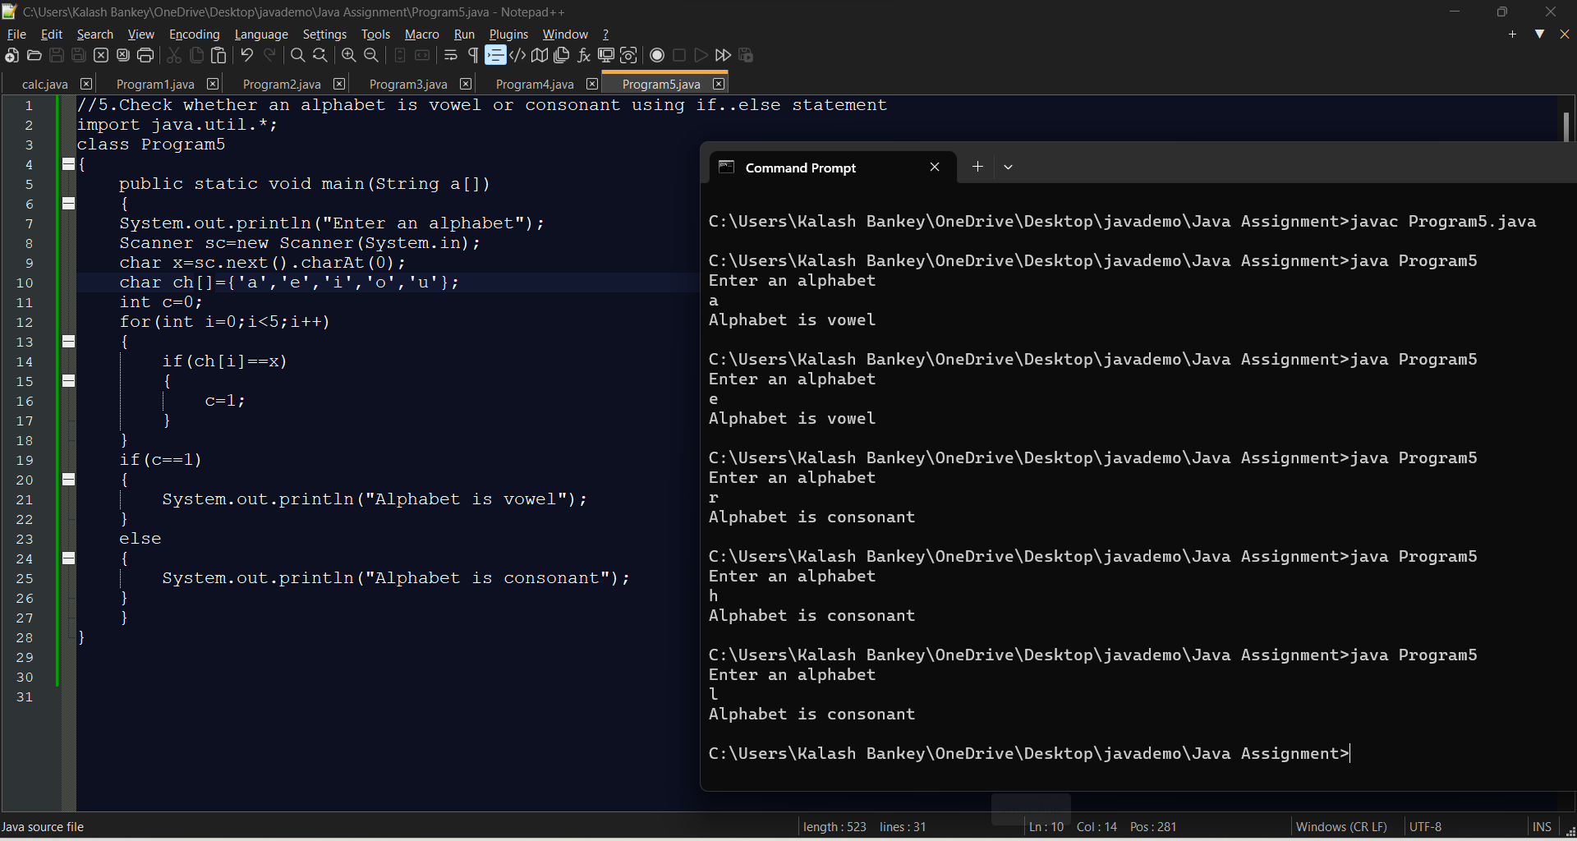

**//6.Check if a Number is Positive or Negative using if else**

import java.util.*;

class Program6

{

public static void main(String a[])

{

System.out.println("Enter an Integer:-");

Scanner sc=new Scanner(System.in);

int x=sc.nextInt();

if(x>0)

{

System.out.println(x+" is positive integer.");

}

else if(x<0)

{

System.out.println(x+" is negative integer.");

}

else

{

System.out.println("x is neither positive nor negative integer.");

}

}

}

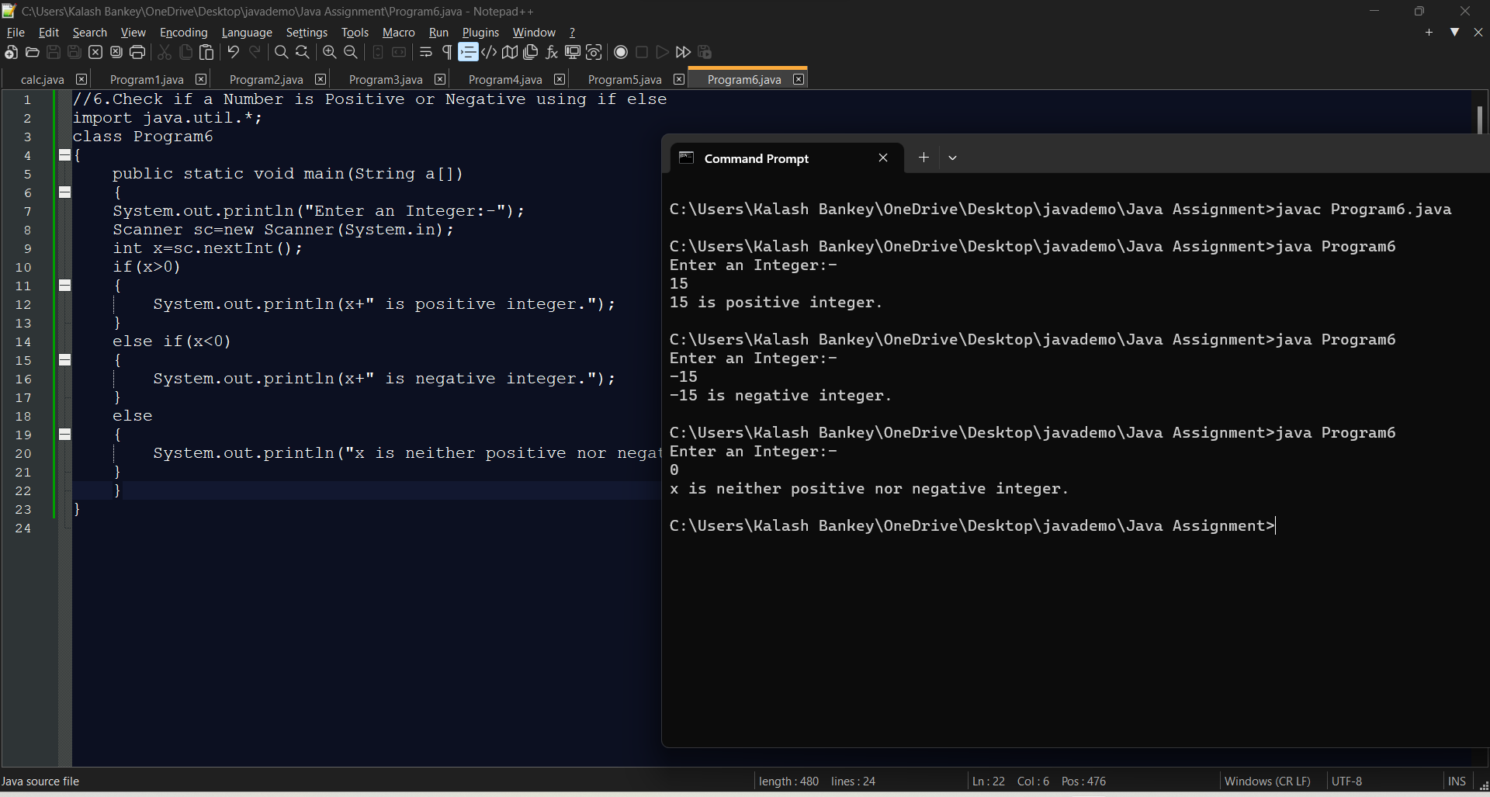

**//7.Sum of Natural Numbers using for loop**

import java.util.*;

class Program7

{

public static void main(String a[])

{

System.out.println("Enter value of n:-");

Scanner sc=new Scanner(System.in);

int n=sc.nextInt();

int sum=0;

for(int i=1;i<=n;i++)

{

sum=sum+i;

}

System.out.println("Sum of first " + n + " Natural Numbers is = "+sum);

}

}

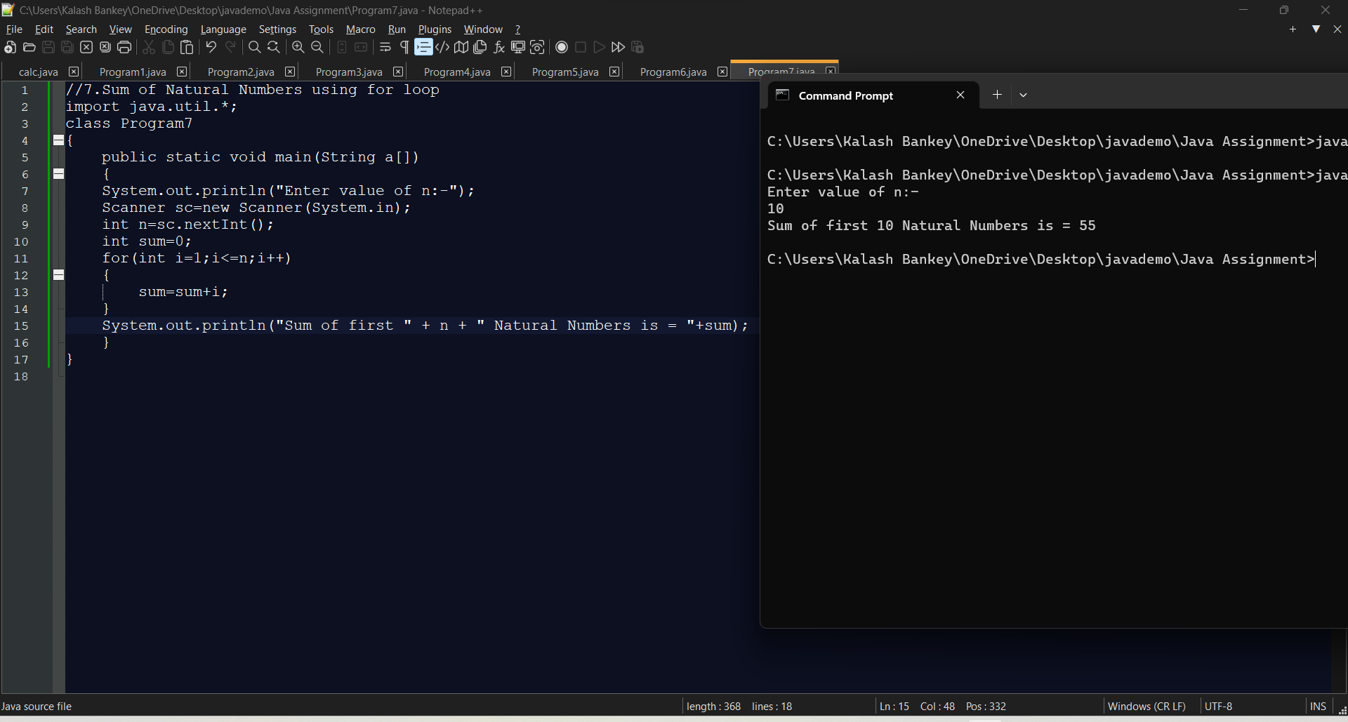

**//8.Find Factorial of a number using for loop**

import java.util.*;

class Program8

{

public static void main(String a[])

{

System.out.println("Enter a number:-");

Scanner sc=new Scanner(System.in);

int n=sc.nextInt();

int fact=1;

for(int i=1;i<=n;i++)

{

fact=fact*i;

}

System.out.println("Factorial of a number "+n+" is = "+fact);

}

}

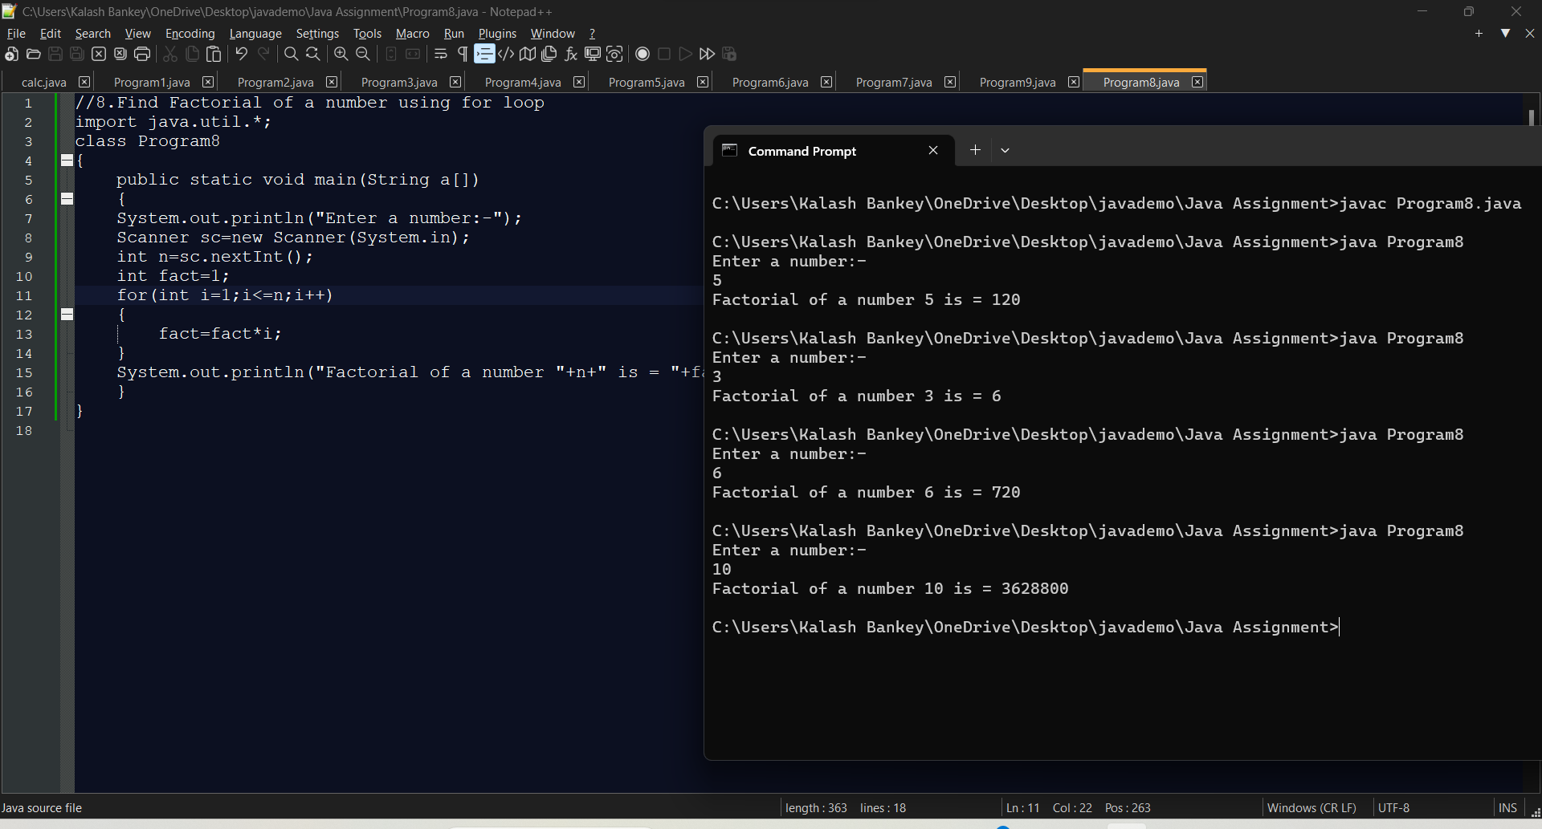

**//9.Generate Multiplication Table using for loop**

import java.util.*;

class Program9

{

public static void main(String a[])

{

System.out.println("Multiplication Table for number:-");

Scanner sc=new Scanner(System.in);

int n=sc.nextInt();

for(int i=1;i<=10;i++)

{

System.out.println(n+"x"+i+"="+n*i);

}

}

}

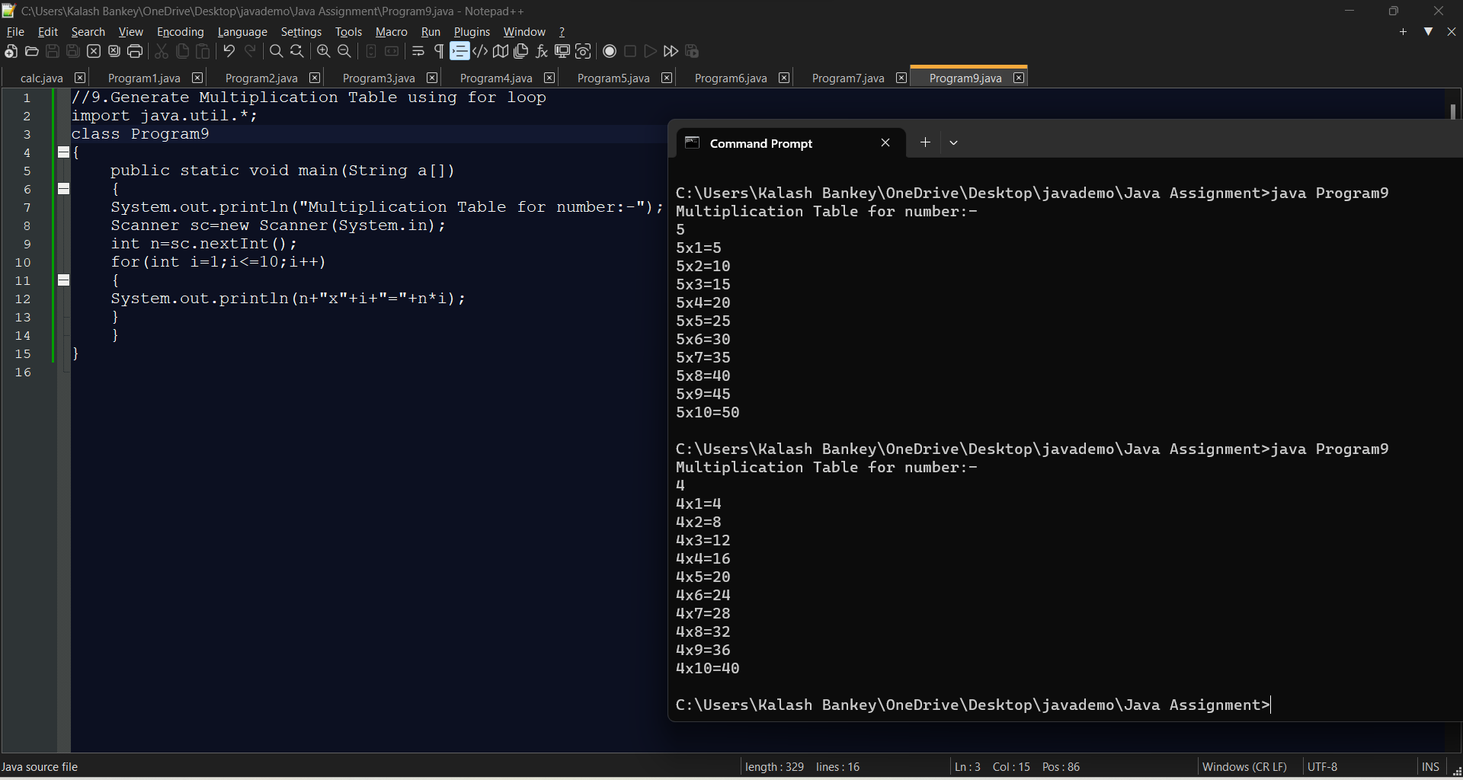

**//10.Display uppercased alphabet A to Z using for loop**

class Program10

{

public static void main(String a[])

{

int x=65;

for(int i=1;i<=26;i++)

{

System.out.printf("%c ",x++);

}

}

}

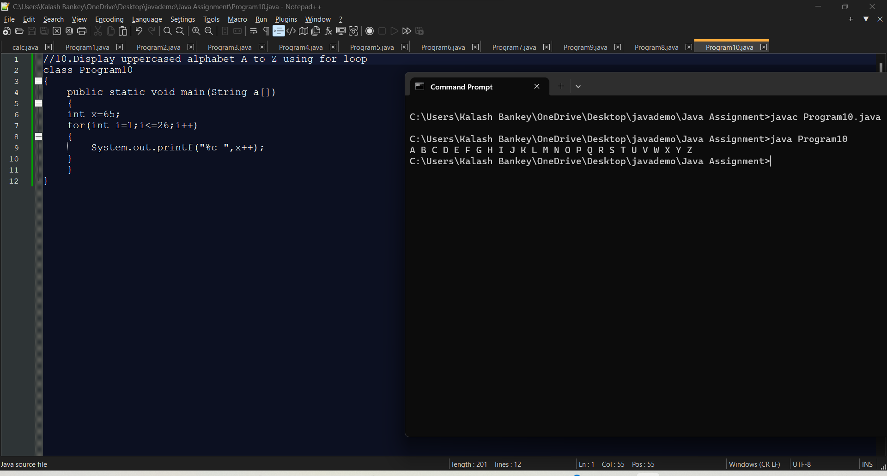

**//11.Find GCD of two numbers using for loop and if statement**

import java.util.*;

class Program11

{

public static void main(String a[])

{

System.out.println("Enter two Integers:-");

Scanner sc=new Scanner(System.in);

int n1=sc.nextInt();

int n2=sc.nextInt();

int gcd=1;

int l;

if(n1>n2) l=n2;

else l=n1;

for(int i=2;i<=l;)

{

if(n1%i==0 && n2%i==0)

{

gcd=gcd*i;

n1=n1/i;

n2=n2/i;

}

else i++;

}

System.out.println("GCD of n1 & n2 = " + gcd);

}

}

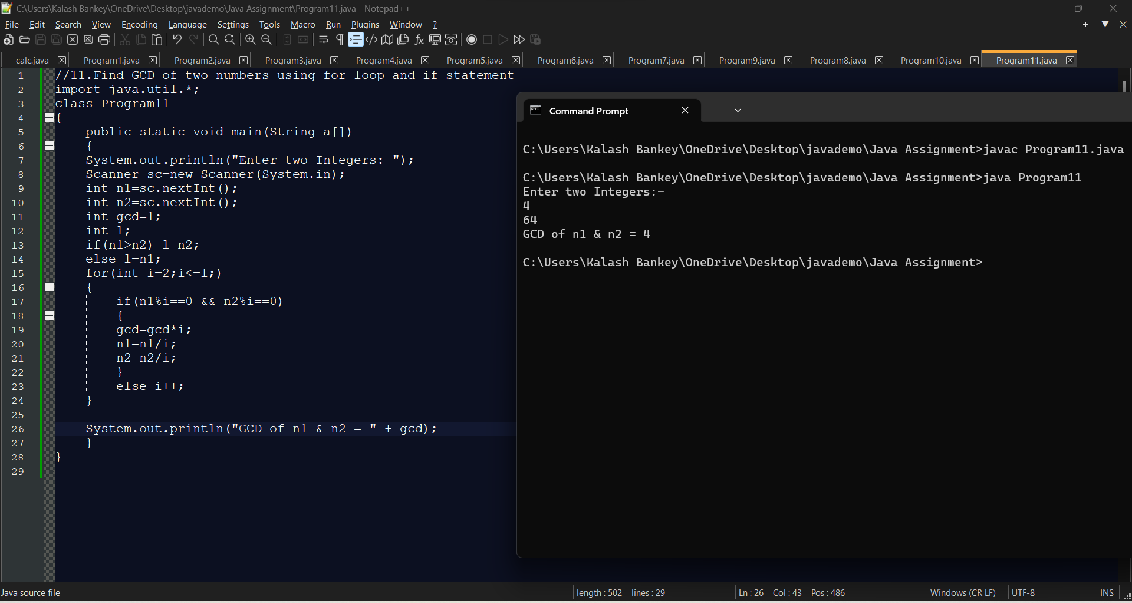

**//12.Java Program to Reverse the number**

import java.util.*;

class Program12

{

public static void main(String ar[])

{

System.out.println("Enter a number:-");

Scanner sc=new Scanner(System.in);

int n=sc.nextInt();

int a,n1=n;

int sum=0;

while(n!=0)

{

a=n%10;

sum=sum*10+a;

n=n/10;

}

System.out.println("Reverse of "+n1+" is "+sum);

}

}

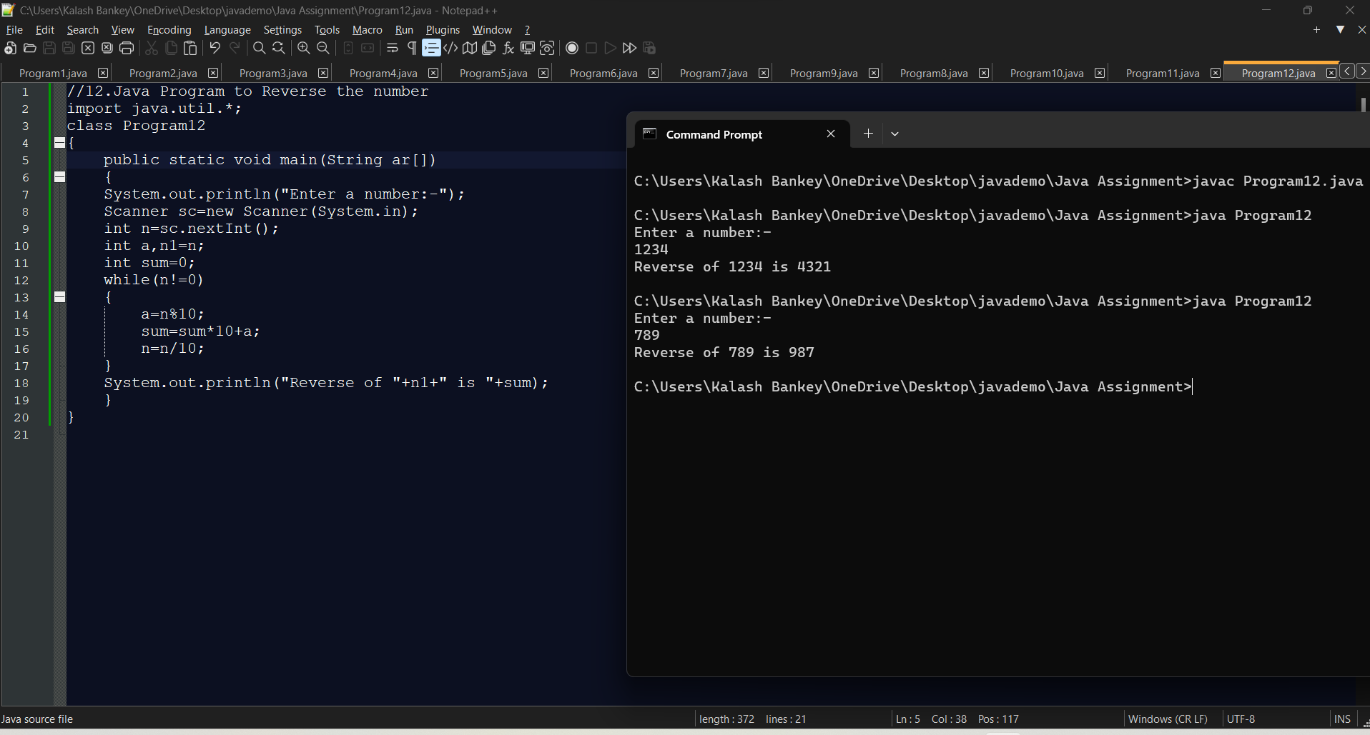

**//13.Demonstrate creating a class and Instance(object)**

class A

{

void show()

{

System.out.println("Class A");

}

}

class Program13

{

public static void main(String a[])

{

A a1=new A();

a1.show();

}

}

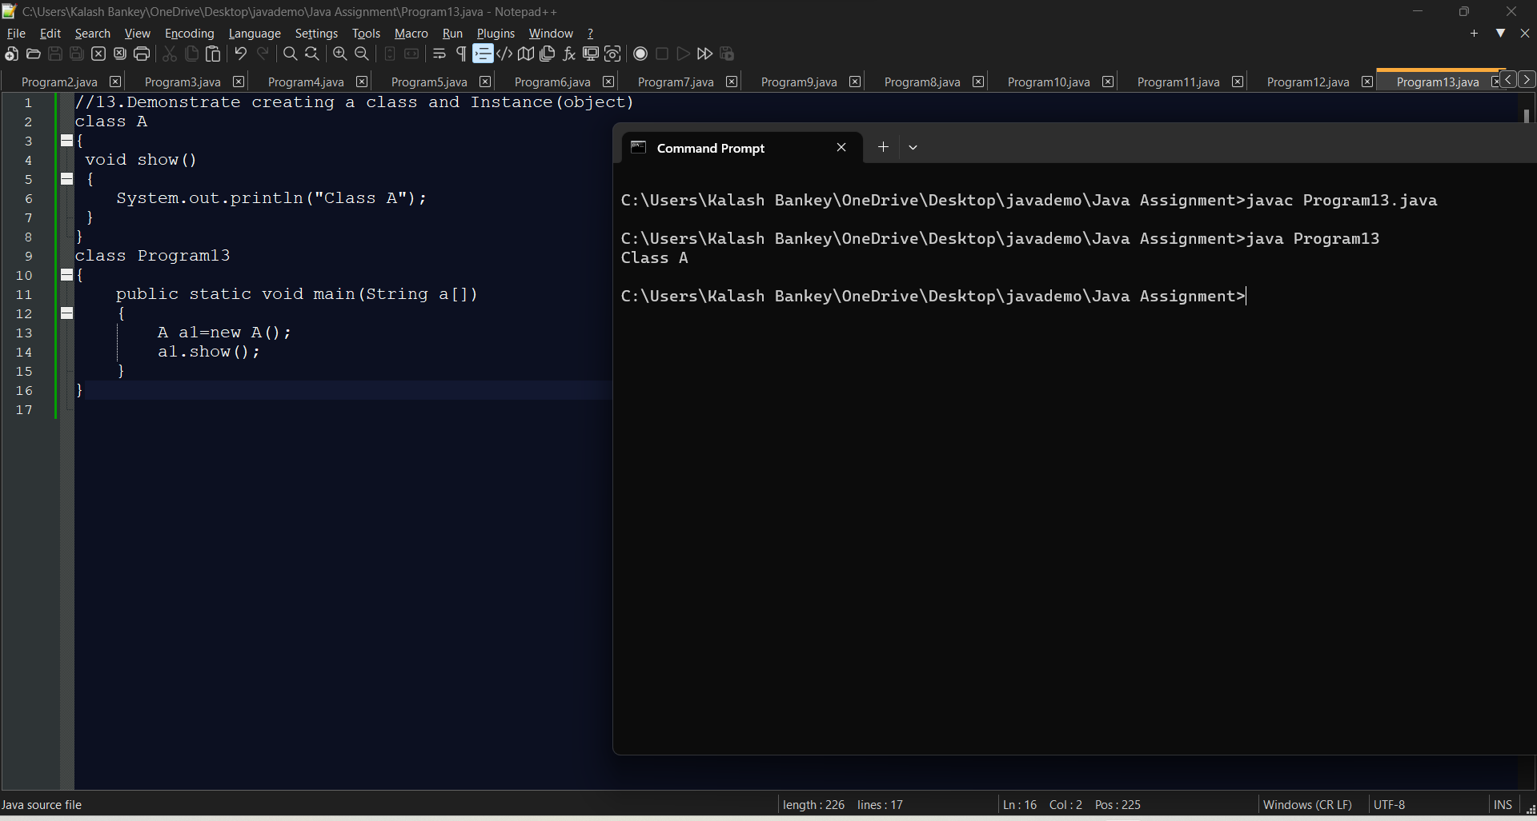

**//14.Demonstrate using Instance/class Variable in a Java Program by creating a simple public class**

class A

{

int x;

void show()

{

x=10;

System.out.println("x = "+x);

}

}

public class Program14

{

public static void main(String a[])

{

A a1=new A();

a1.show();

}

}

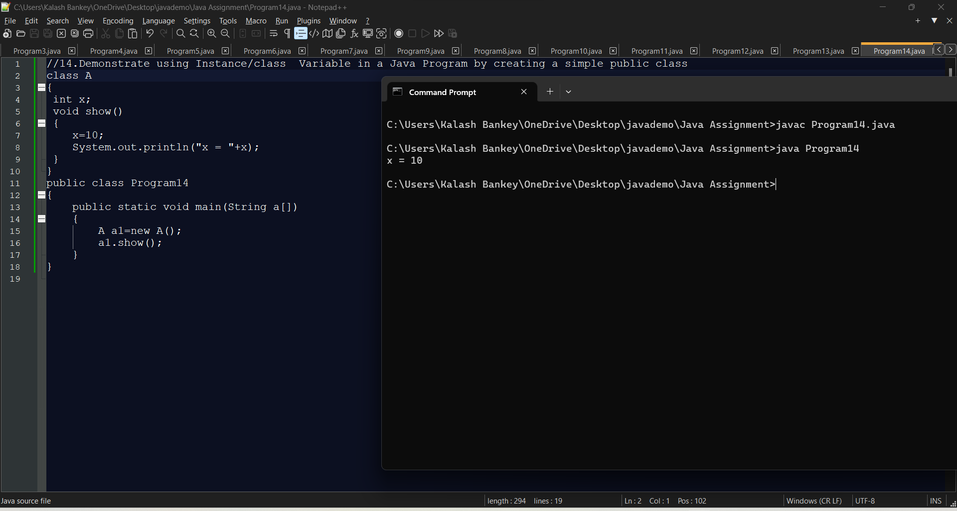

**//15.Demonstrate the java class using getter setter method for accessing private data members**

class A

{

int x;

int y;

public void getter(int a,int b)

{

x=a;

y=b;

}

void setter()

{

System.out.println("x = "+x);

System.out.println("y = "+y);

}

}

public class Program15

{

public static void main(String a[])

{

A a1=new A();

a1.setter();

a1.getter(10,20);

a1.setter();

}

}

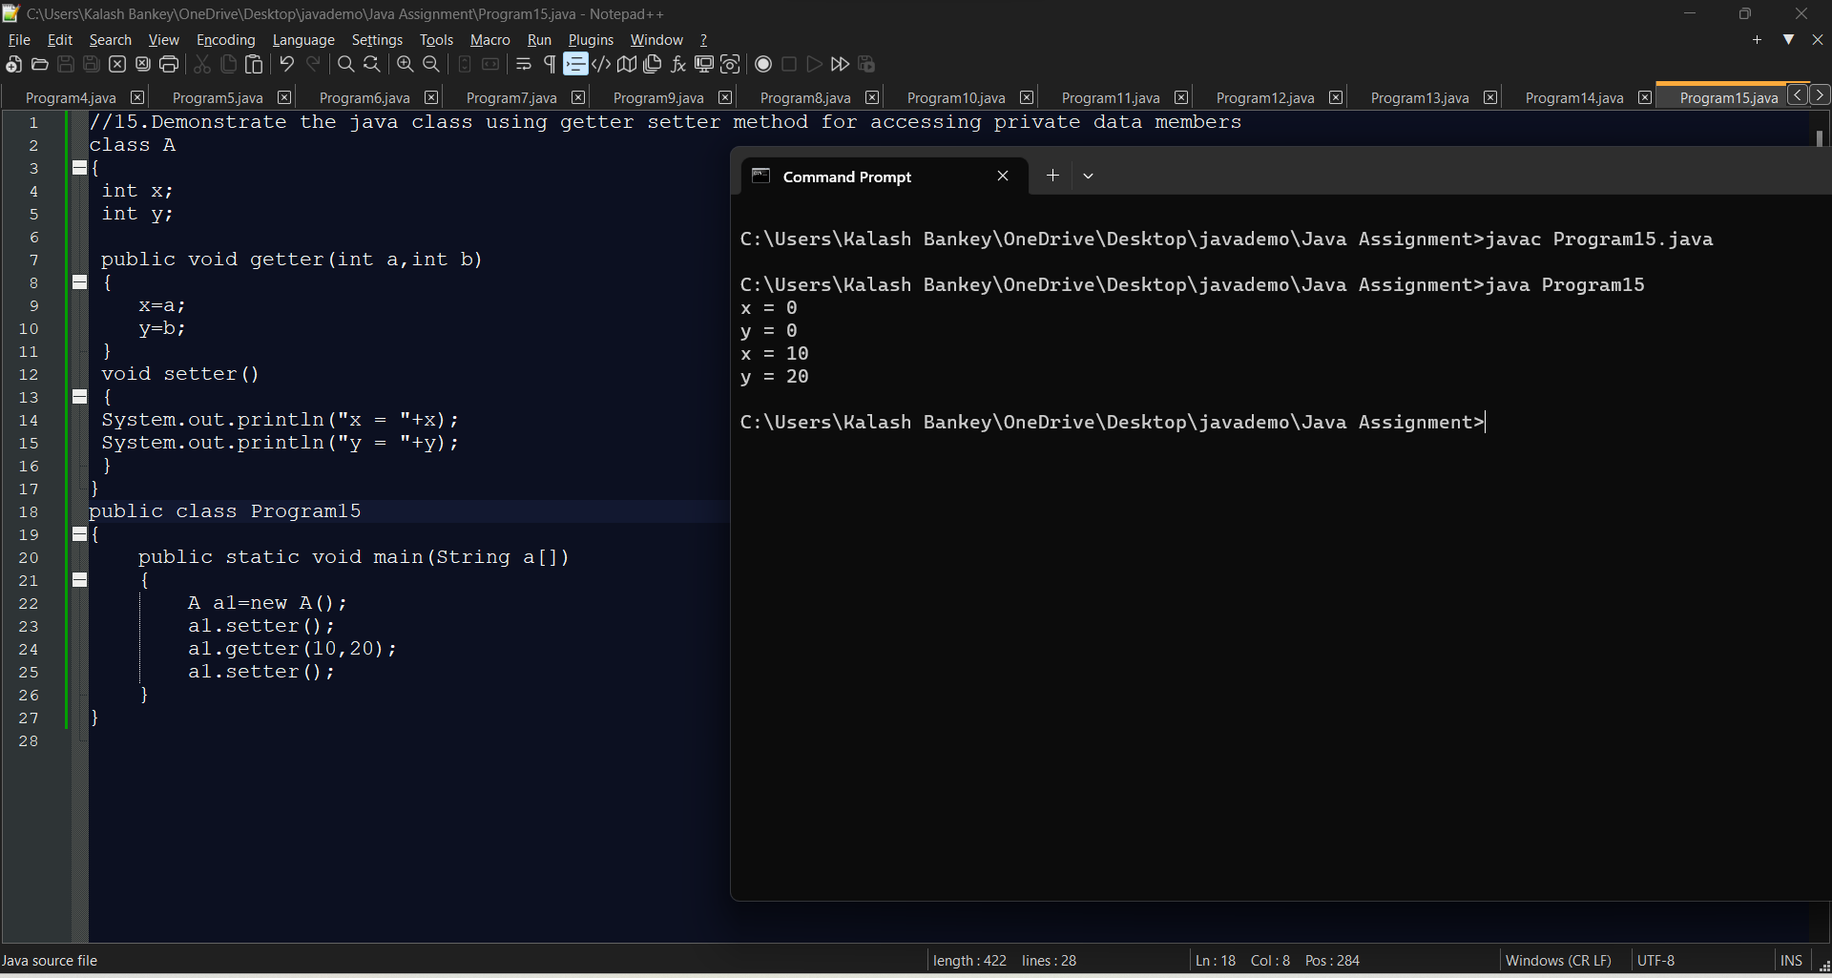

**//16.Demonstrate the use of static variable**

class A

{

static int x=10;

void show()

{

System.out.println(x++);

}

}

public class Program16

{

public static void main(String a[])

{

A a1=new A();

A a2=new A();

A a3=new A();

a1.show();

a2.show();

a1.show();

a3.show();

a2.show();

a1.show();

}

}

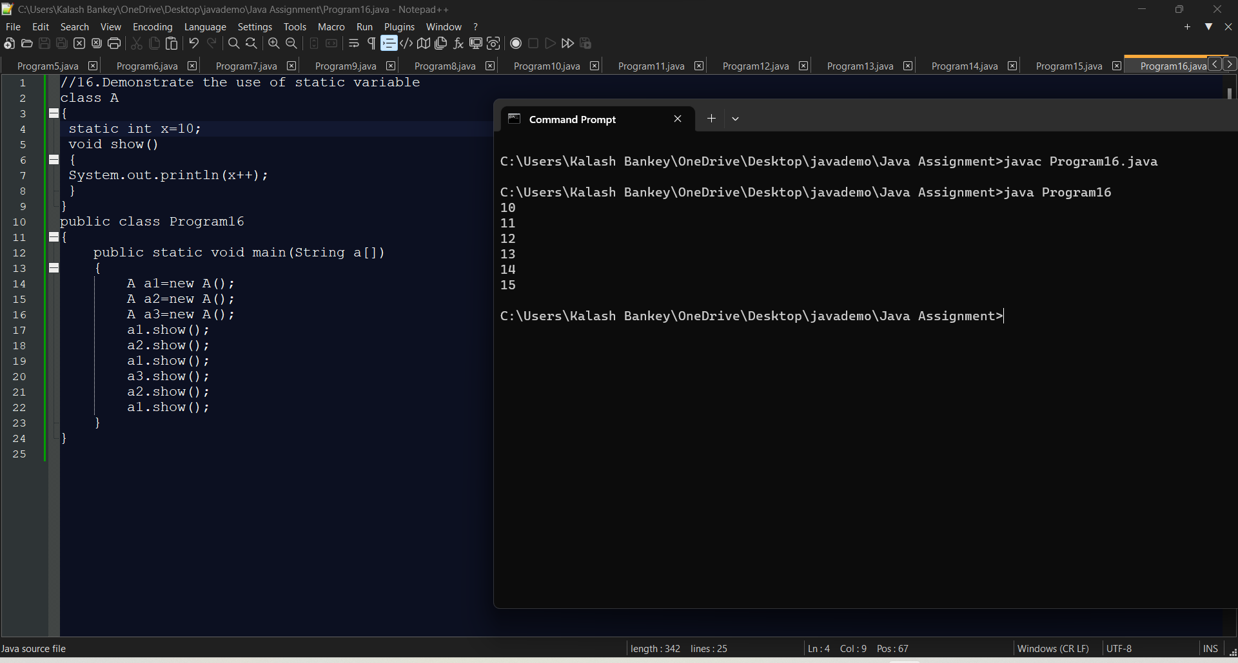

**//17.Demonstrate the use of static method**

class A

{

static int x=10;

static void show()

{

System.out.println(++x);

}

}

public class Program17

{

public static void main(String a[])

{

A.show();

}

}

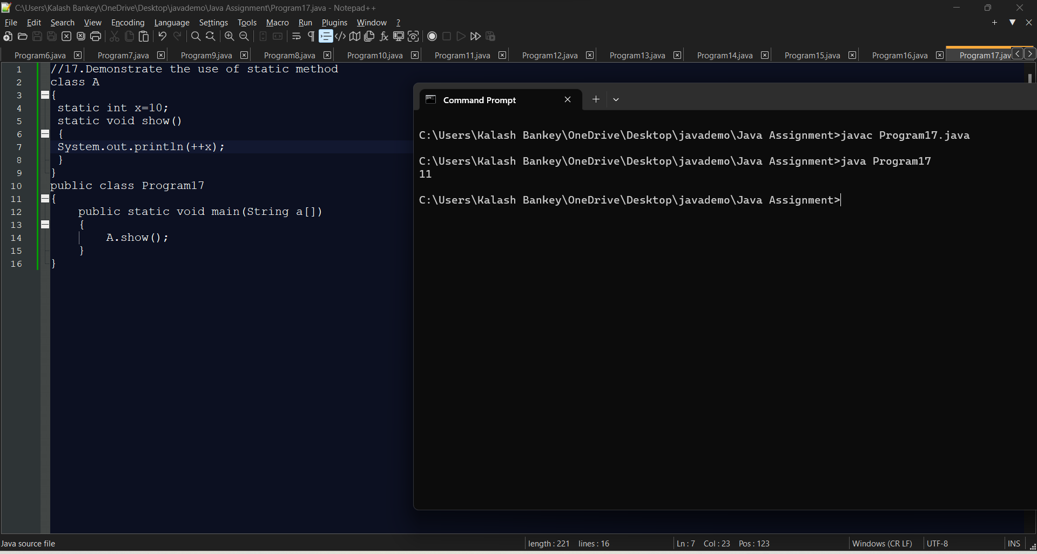

**//18.Demonstrate the use Scanner class for taking Input /Output from user**

import java.util.*;

class Program18

{

public static void main(String a[])

{

System.out.println("Enter two Integers:-");

Scanner sc=new Scanner(System.in);

int n1=sc.nextInt();

int n2=sc.nextInt();

System.out.println("n1 = " + n1);

System.out.println("n2 = " + n2);

}

}

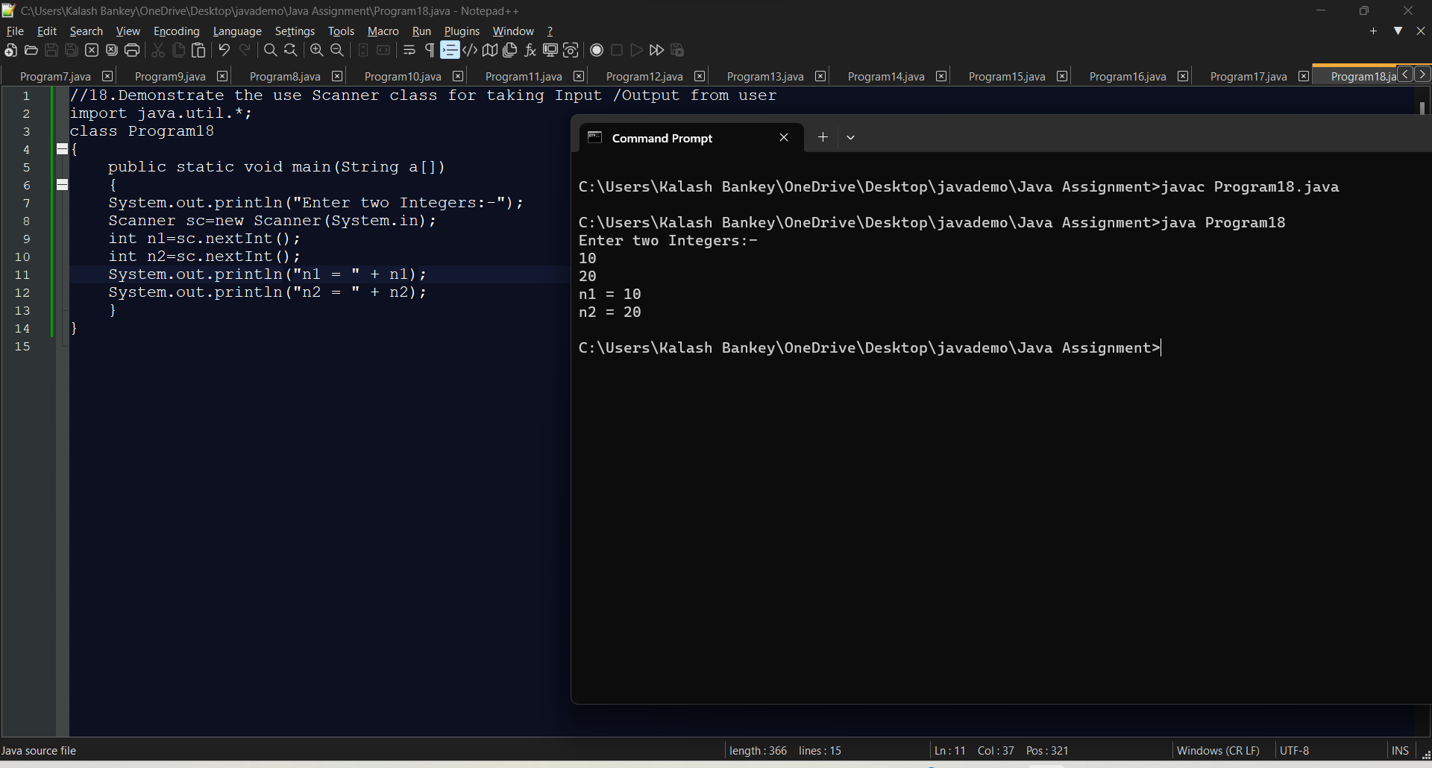

**/*19.Create a program in java to create a class named Light. It contains a variable: On and two methods: switchOn() and switchOff().**

**Inside the Main class, create two objects: led and halogen of the Light class. Then use the objects to call the methods of the class.**

**led.turnOn() - It sets the On variable to true and prints the output.**

**halogen.turnOff() - It sets the On variable to false and prints the output.**

**\*/**

class Light

{

boolean on;

void switchOn()

{

on = true;

System.out.println("LED ON");

}

void switchOff()

{

on = false;

System.out.println("HALOGEN OFF");

}

}

class Program19

{

public static void main(String a[])

{

Light led=new Light();

Light halogen=new Light();

led.switchOn();

halogen.switchOff();

}

}

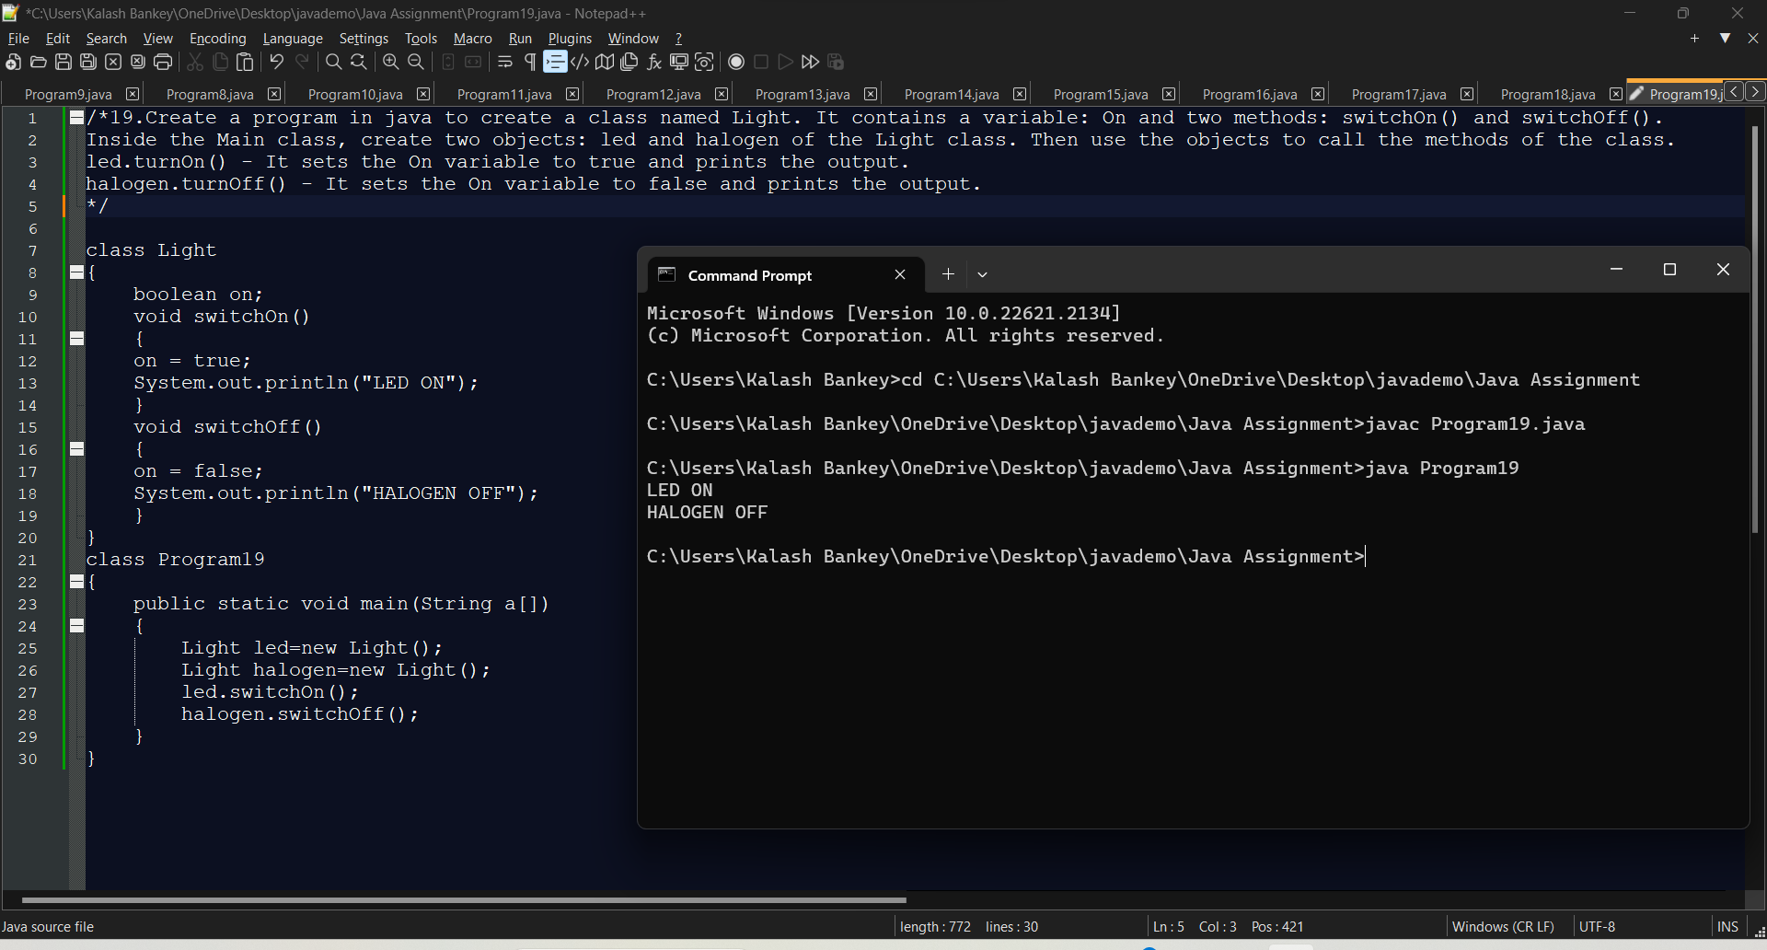

**/*20.Create a program in java to create a class Box with private members as length, breadth, height.**

**Create two methods getDimension() , setDimension() to set and get values. Create instances of this class to call the methods.**

**\*/**

class Box

{

int length;

int breadth;

int height;

void getDimension(int a,int b,int c)

{

length=a;

breadth=b;

height=c;

}

void setDimension()

{

System.out.println("Length = "+length);

System.out.println("Breadth = "+breadth);

System.out.println("Height = "+height);

}}

class Program20

{

public static void main(String a[]){

Box b1=new Box();

Box b2=new Box();

System.out.println("Dimensions of box b1");

b1.getDimension(10,20,30);

b1.setDimension();

System.out.println("Dimensions of box b1");

b2.getDimension(100,200,300);

b2.setDimension();

}}

